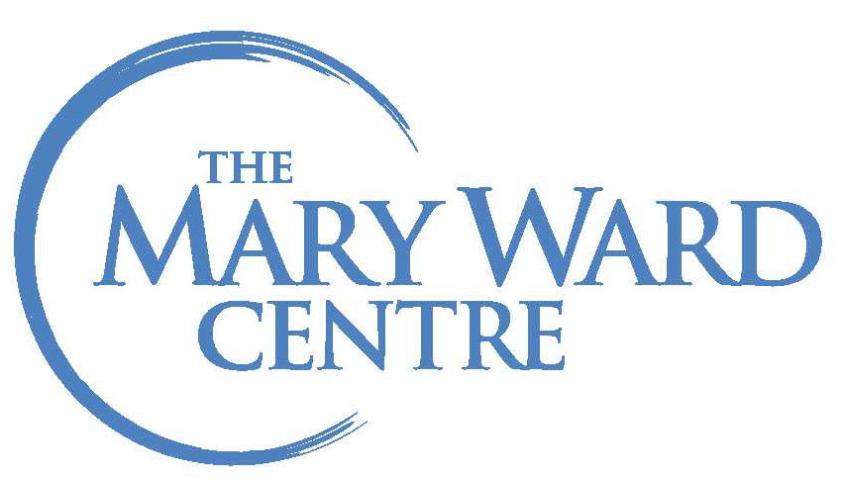

CRC National JPIC Gathering 2017
Accommodation Application

70 St. Mary St. ● Toronto, ON ● M5S 1J3
Phone: 416-925-2833 ● Fax: 416-925-2977 ● E-mail: info.marywardcentre@gmail.com

Name: |  |  |  | Male Female
Address:
City: |  | Province/State:
Postal Code: |  | Country:
Telephone (h):
Telephone (w):
E-mail:

Rate: $60/night includes breakfast

Arrival Date:
Departure Date:
If you have any special dietary needs, please let the kitchen know upon your arrival.

CREDIT CARD | Credit Card Type | Visa |  | MasterCard
 | Credit Card Number:
 | Expiry Date:
 | Signature
CHEQUE | Cheque Number:

Please send this accommodation form and payment directly to:

Ann McGowan
70 St Mary St.
Toronto ON M5S 1J3

Email Address: info.marywardcentre@gmail.com

