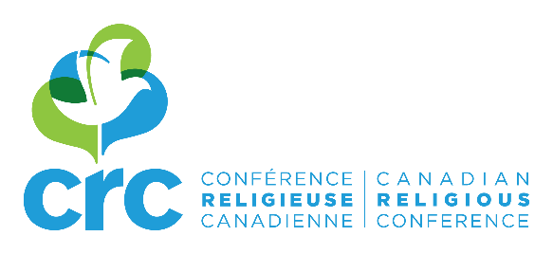

REGISTRATION FORM

Beyond Truth and Reconciliation in Atlantic Canada
Halifax, September 13, 2017 (8:30 am – 3:00 pm)

St. Agnes Church

6903 Mumford Rd.

Halifax, NS B3L 2H4

Cost: $40 (lunch included)

Name:
Community:
Please, check your status:
☐ Congregational Leader
☐ Congregational Member
☐ Lay Associate
☐ Lay Person
E-mail:

Please use one registration form per participant and send them by e-mail to Nathalie Gauthier: ngauthier@crc-canada.org.

PAYMENT WILL BE AT THE DOOR.

Means of payment:
- Cash
- Cheque (payable to “Canadian Religious Conference”)

If you register several persons, please join one cheque for all participants.

Information and registration:
Nathalie Gauthier, ngauthier@crc-canada.org, 514 259-0856 Ext. 107
www.crc-canada.org

